Curriculum Vita
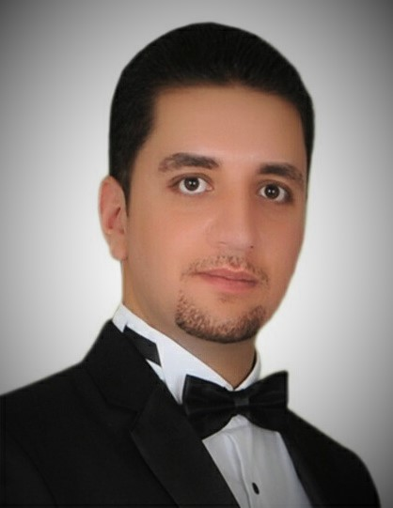
Name: Sary Mahir Ailia Shaawi
Date and place of Birth: 15/8/1986 Baghdad.
Marital status: Married with two children.
Nationality: Iraqi / Chaldean
Religion: Christian
Work: Lecturer
Presently: Lecturer at University of Duhok/ College of agricultural engineering sciences /Agriculture extension and rural development Department.

Previously:
Sulaimani Polytechnic University/ College of applied sciences/ Halabja
- Lecturer at Food Industries Department. (from 2012 to 2016).
- Member of the department council. (from 2012 to 2016).
- Member of the Examination committee (2015-2016).
- Lecturer at Animal Resource Department. (from 2016 to 2018)
- Member of the department council. (from 2016 to 2018)
- Lecturer at Food Industries Department and quality control (from 2018 to 2020)
- Member of the department council. (from 2018 to 2020)
- Member of the scientific committee in the department. (from 2018 to 2020)

Education background:
  - B.Sc. Animal Production. University of Mosul, very good degree.
2008-2010 M.Sc. Animal nutrition. University of Mosul, very good degree.

My master Thesis:
Effect of addition of methionine, lysine and protein treated with formaldehyde on milk yield and composition in Awassi Turkish sheep.
Scientific Degree:
- Assistant Lecturer
2017 Lecturer

Scientific Papers:
- The effect of high doses of fish oil as a source of (omega-3) in the production and physiological performance in local rabbits. journal of Tikrit university for agriculture (2016). vol (16-3).
- The effect of orphan lamb drenching with methionine and lysine in growth rate, rumen parameters, and some of hematological and blood biochemical parameters. Journal of Tikrit University for agriculture (2017). Vol (17-2).
- Using linear equations approach to formulate balanced and least-cost ration for dairy cattle. (Acceptance Letter and Participation in A conference)

Appreciation
I have (7) Certificate of Appreciation.

Training courses(I got):
- Training course in the collage of agriculture, Aleppo University. (2007).
- IC3 training course in Mosul University. (2008).
- I got a Certification from CCTI (Crisis Care Training International) to offering healing and hope for children in Crisis module one: (Trauma and Crisis Care).

Training courses(I gave):

(8) Training courses for under graduated students of Food industries and quality control department (from 2011-2020)

(1) work shop for Butches and Shepherd (Meat from farm to the plate) (2019)
3- Training course (food processing ToT training)

Languages: Arabic, English and some of Kurdish.

Graduate Courses:
- Principles of food science.
- Animal health and diseases
- Livestock production

Address and Contact:
University of Duhok/ College of agricultural engineering sciences /Agriculture extension and rural development Department.
Mobile: 07702002977
07515161788
Viber : 07702002977
WhatsApp: 07702002977
E-mail : sari_mahir@yahoo.com
sarymahir@gmail.com
sary.mahir@uod.ac

