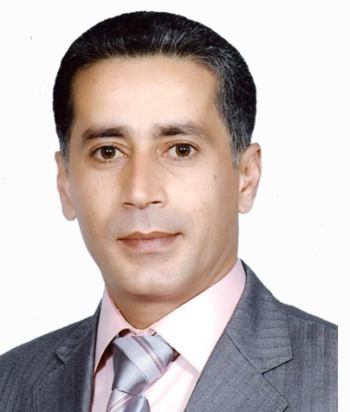
Curriculum Vita
Personal information
Full Name: Dr. Khalid Ismail Saleem
Academic title: Lecturer
Teaching at University: since 1999
Number of years working as university teacher: 21 Years
University: Duhok
College: Agricultural Engineering Sciences
Department: Forestry
Phone no. : 00964-750-4714078
E-Mail: khalid.ismail@uod.ac
Education and Academic certificates
Certificate Specialization/department University Country Year granted
Bachelors: Plant Production Duhok Iraq 1996
Master: Rangeland Management Duhok Iraq 1999
PhD: Rangeland Management Duhok Iraq 2011
Academic Scientific title
Academic Scientific title Year granted Place Country
Assistant lecturer: 1999 Duhok University Iraq
Lecturer: 2011 Duhok University Iraq
Committee membership: Forestry department committee
Language qualification
Language Mother tongue Very good Good
Kurdish: √
Arabic: √
English: √

Teaching at University
Rangeland Management: Postgraduate Forestry department
Academic Debates: First Stage Forestry department
Rangeland Management: Third stage Forestry department

Numbers of Defending sessions of postgraduate students: 3
Published research: 2
Union Membership:
Kurdistan Agricultural Engineering Union: since 1996
Kurdistan Universities’ teachers: since 2010
Kurdistan teachers Union: since 2000

