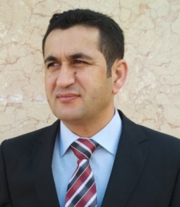 | Full name | Hishiar Saeed Abdi
 | e. mail | Hishiar.abdi@uod.ac
 | Academic Rank | lecturer  Forestry department
 | Degrees | MSc.
 | Specialization | Forestry
 | Research interests
C.V

Hshiar Saeed Abdi
B.Sc. Agriculture University of Dohuk
M.Sc. Science , Biology, fORESTRY
Personal Data
Surname: Abdi
Forenames: Hishiar Abdi
Gender: Male
Marital Status:
Date and Place of Birth: 1/2/1974 Sarsink, Dohuk , Iraq
Nationality: Iraqi
Academic Status: lecturer
Languages: Kurdish (mother tongue), English and Arabic (spoken and written)
Address for Correspondence: Dept. of Biology, Faculty of Science, Kurdistan Region, Iraq.
E-mail: Hishiar.abdi@uod.ac
Mobile Phone: 00964 750 4508732
Education and Qualifications
- Schooling
1990-1996 Goran Primary School, Sarsink
1996-1998 Sarsink Intermediate School, Sarsink
1998-2002 Birayety High School, Duhok
- University
1996-1999 B.Sc. study in the Dept. of Forestry, College of Agriculture, University of Duhok, Iraq.
2009-2011 M.Sc. study in the Dept. of Forestry, College of Agriculture, University of Duhok , Kurdistan, Iraq.

