Personal Information |  | 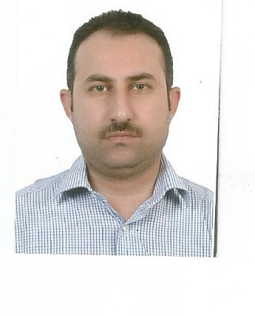
Name | Bahzad Sabri Maran
Nationality | Iraqi
Date of Birth | 27-11-1978
Place of Birth | Duhok | Marital Status | single
Contact Information
E-mail | Bahzad.maran@uod.ac | E-mail | bahzadsm@yahoo.com
Home Address  (Permanent Address) | Duhok-KRO-Bahdinan-Jin | Mobile No. | 009647504080310
Education
Degree | Bachelor | Master | Scientific Title
University Name | Duhok | Duhok | Lecturer assistant
Country | Iraq | Iraq
Date of obtaining degree (Day/Month/Year) | 20-7-2003 | 4-1-2006 | 4-2-2006
Bachelor (Major /Specialization) |  | Business administration
Master (Major / Specialization) |  | Business administration-financial management
Title of Master Thesis |  | The inflations effect on financial performance
Title of PhD. Dissertation

Experience in University of Duhok- Iraq
From  D/M/Y | To  D/M/Y | Position /Title | Nature of work
Courses Taught
Credit and investment management
Financial management
Principles of management
Credit management
Readings in economics
Financial and banking institutions management
Marketing research’s
Readings in banking
Financial management
SPSS
Material management
Banking management
Readings in management
Activities
Scientific Research Published |  | Journal /Institution | No. and Volume/Year
The effects of demographic factors on information resources of durable goods |  | Polie tacnic Erbil | No.1 vol.5
Conferences |  | University-City | Year
Subjects Teaching
Principles of management
Computer Skills
Software / Program | Level
Word | Very good
Excel | Very good
Language Skills
Language | Level
Kurdish and Arabic | Excellent
English | Good
Other

