Personal Information |  |  |  |  |  |  | 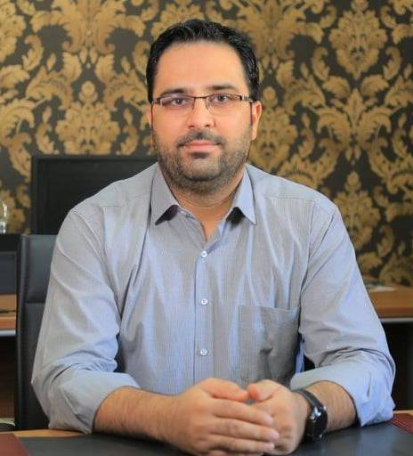
Name |  | Shivan Abdulahman Jameel
Nationality |  | Iraqi – Kurdish
Date of Birth |  | 1984
Place of Birth |  | Duhok |  |  |  |  | Marital Status | Married
Contact Information
E-mail |  |  | Shivan.duhoky@gmail.com |  |  |  | E-mail | Shivan.a.jameel@uod.ac
Home Address  (Permanent Address) |  |  | Duhok - Hawshki |  |  |  | Mobile No. | 009647504807547
Education
Degree |  |  |  | Bachelor |  |  | Master |  | Scientific Title
University Name |  |  |  | Duhok |  |  | Huddersfield |  | Lecturer
Country |  |  |  | Iraq |  |  | United Kingdom
Date of obtaining degree (Day/Month/Year) |  |  |  | 06/07/2009 |  |  | 13/03/2013
Bachelor (Major /Specialization) |  |  |  |  |  |  | Business Administration
Master (Major / Specialization) |  |  |  |  |  |  | Business Administration / International Business with Financial Services
Title of Master Thesis |  |  |  |  |  |  | Evaluation Configuration of Entrepreneurial University in the UK.
Title of PhD. Dissertation

Experience in University of Duhok- Iraq
From  D/M/Y | To  D/M/Y |  |  |  |  | Position /Title |  |  | Nature of work
2009/7/1 | 2011/2/10 |  |  |  |  | Manager of Planning Unit  College of Law & Political Science
2013 | Ongoing |  |  |  |  | Lecturing at University
Courses Taught
Public Administration
Principles of Management
Strategic Management
Marketing Management
Management Reading in English
Public Relation
Fund Management
Research Methods
Scientific Discussion
Seminars in English
English Language
Natural Tourism
Hotel Information System
Activities
Scientific Research Published |  |  |  |  |  |  | Journal /Institution |  |  | No. and Volume/Year
Customer's Awareness towards the Islamic Banking System |  |  |  |  |  |  | Humanities Journal of University of Zakho |  |  | Volume 5, No 1 (2017)
The Role of Emotional Intelligence on Achieving Administrative Innovation |  |  |  |  |  |  | Academic Journal of Nawroz University |  |  | Volume 6, No 2 (2017)
The Role of Liquidity Management in Profitability. |  |  |  |  |  |  | Academic Journal of Nawroz University |  |  | Volume 8, No  4 (2019)
The Possibility of Building the Relationship with the Customer in Service Organizations |  |  |  |  |  |  | Academic Journal of Nawroz University |  |  | Volume 9, No 4 (2020)
The Impact of Foreign Direct Investment on Gross Domestic Product in Iraq. |  |  |  |  |  |  | Academic Journal of Nawroz University |  |  | Volume 10, No 1 (2021)
Conferences |  |  |  |  |  |  | University-City |  |  | Year
Towards New scientific horizons for building Kurdistan Region |  |  |  |  |  |  | Cihan University - Duhok |  |  | 2017
Bologna Process Implementation |  |  |  |  |  |  | Cihan University - Duhok |  |  | 2019
International Experiences in E-Learning in Light of the Coronavirus |  |  |  |  |  |  | Cihan University - Duhok |  |  | 2021
Evaluating the Iraqi Oil Sector |  |  |  |  |  |  | Cihan University - Duhok |  |  | 2021
Software: Tool for Change |  |  |  |  |  |  | Cihan University - Duhok |  |  | 2021
Subjects Teaching
Hotel Information System
Scientific Discussion
Computer Skills
Software / Program |  |  |  |  | Level
Microsoft Office |  |  |  |  | Professional
SPSS |  |  |  |  | Professional
Language Skills
Language |  |  |  |  | Level
Kurdish |  |  |  |  | Mother Tongue
Arabic |  |  |  |  | Professional
English |  |  |  |  | Professional
Other

