Personal Information |  |  |  |  |  |  |  |  | p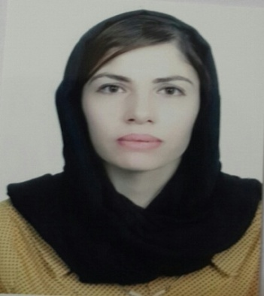hoto
Name |  | Nasreen Mohamed Taher Saadi
Nationality |  | Kurdish
Date of Birth |  | 15/2/1987
Place of Birth |  | semel |  |  |  |  |  |  | Marital Status |  | singl
Contact Information
E-mail |  |  | Nasreen.alhakim@yahoo.com |  |  |  |  |  |  | E-mail |  | Nasreen.saadi@uod.ac
Home Address  (Permanent Address) |  |  | Semel/mserek |  |  |  |  |  |  | Mobile No. |  | 0096407504045383
Education
Degree |  |  |  | Bachelor |  |  | Master |  |  |  |  |  | Scientific Title
University Name |  |  |  | University of Duhok |  |  | University of Duhok |  |  |  |  |  | Lecturer
Country |  |  |  | Iraq |  |  | Iraq
Date of obtaining degree (Day/Month/Year) |  |  |  | 18/7/2009 |  |  | 31/3/2021
Bachelor (Major /Specialization) |  |  |  |  |  |  | Financial and banking Sciences
Master (Major / Specialization) |  |  |  |  |  |  | Financial and banking Sciences - banks management
Title of Master Thesis |  |  |  |  |  |  | Th rple of sam organizational and financial determinants in the creation oh a financial struktor
Title of PhD. Dissertation  (FAU Erlangen~Nuremberg ) |  |  |  |  |  |  | The mediating role of the valium of cash credit in the ralaton ship of the out puts of the banking inquire system and the determinants of creditin credit in credit Distress
Experience in University of Duhok- Iraq
From  D/M/Y | To  D/M/Y |  |  |  |  | Position /Title |  |  |  |  |  |  |  | Nature of work
2020 | Now |  |  |  |  | scheduled  the Department of Banking and Financial Sciences andLecturer
1/9/2009 | 6/5/2009 |  |  |  |  | Employees in the unit at the college registration
Courses Taught
Banking oparetion system
Banking oparetion system
Activities
Scientific Research Published |  |  |  |  |  |  |  | Journal /Institution |  |  |  |  |  |  | No. and Volume/Year
The role of actors in finding electronic solutions for electronic services, and government, electronic devices, an exploratory study |  |  |  |  |  |  |  | polytechnic Journalin Erbil |  |  |  |  |  |  | /2014
Evaluation of the financial performance of the Bank of Baghdad for the period from (2006-2011) a comparative study between the models (CAMEL) and (modern financial indicators) |  |  |  |  |  |  |  | polytechnic Journalin Erbil |  |  |  |  |  |  | /2014
Assessing the reality of cash credit using the indicators of liquidity and profitability - an analytical study in a sample of private banks registered in the Iraqi Stock Exchange for the period (2005-2011). |  |  |  |  |  |  |  | Duhook universityJournal |  |  |  |  |  |  | /2014
The sequential effect of a number of credit determinants to reduce credit default through the volume of cash credit |  |  |  |  |  |  |  | Nawroz Journal |  |  |  |  |  |  | 2020
The effect of the outputs of the banking inquiry system in reducing credit default |  |  |  |  |  |  |  | Nawroz Journal |  |  |  |  |  |  | 2020
The effect of the efficiency of the quantitative tools of monetary policy on the financial soundness of banks |  |  |  |  |  |  |  | Nawroz Journal |  |  |  |  |  |  | 2021
The impact of irregular risks on the degree of banking security |  |  |  |  |  |  |  | Nawroz journal |  |  |  |  |  |  | 2021
Conferences |  |  |  |  |  |  |  | University-City |  |  |  |  |  |  | Year
Alruha 8th international conference on social sciences |  |  |  |  |  |  |  | jordn |  |  |  |  |  |  | 2021
Subjects Teaching
/ Master's/ international finance
Bachelor/banking oparetion system
Computer Skills
Software / Program |  |  |  |  | Level
Microsoftword |  |  |  |  | very good
Microsoft Excel |  |  |  |  | very good
Microsoft PowerPoint |  |  |  |  | very good
Spss |  |  |  |  | Good
Mintab |  |  |  |  | Good
Language Skills
Language |  |  |  |  | Level
Kurdish and Arabic |  |  |  |  | very good
English |  |  |  |  | Good
Other

