CURICULUM VITAE (CV)

Dr Abdulkareem Ramadhan Ibrahim Al-Mezouri
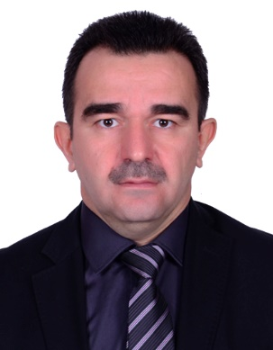
BDS, MSc, PhD (Conservative Dentistry)
Nationality: Iraqi
Languages: Kurdistan, Arabic and English
E mail: abdulkarim_dent@yahoo.com
Abdulkaremm.ramadhan.uod.ae
QUALIFICATIONS:
- B.D.S, Musol University, Iraq, 1993
- M. Sc. in Conservative Dentistry, Mosul University, Iraq, 2007
- Ph. D in Conservative Dentistry, Hawler Medical University, Iraq, 2014
MEBERSHIPS:
- Iraqi Dental Association
- Kurdistan Dental Association
- Iraqi Endodontic Group
DENTAL CONFERENCES:
- FDI dental conference in Dubai 2009.
- FDI dental conference in Dubai 2014.
- Second Iraqi Dental Reunion 2012.
- FDI dental conference in Dubai 2016.
DISCUSSION COMMITTEES:
- Master thesis in the college of Dentistry, University of Mosul.
- Two master theses in the college of Dentistry, Hawler Medical University
SCIENTIFIC COURSES:
- Implant course in B&B implant system, Bologna Italy 2007.
- Implant course in B&B implant system, Duhok, 2008.
- Implant course, Dubai, 2009.
- One-year Master program in implant (Global Institute for Dental Education) Los Angeles, USA, 2012.
- One-year Master program in implant (UCLA) California, USA, 2012.
- English Proficiency course (Training and developing center/University of Duhok, 2009.
- Computer proficiency (Training and developing center/University of Duhok, 2009.
EMPOYMENT HISTOTY:
- 1993-1994 Duhok Dental Polyclinic, Duhok (Vocational training).
- 1995-1997 Sumail Health Center, Duhok.
- 1998-2003 Duhok Dental Polyclinic, Duhok (GDP).
- 2003-2004 Manager of Dental Polyclinic, Duhok.
- 2004-2006 M.Sc student, Mosul University.
- 2006-2009 Manager of Specialized Dental Polyclinic, Duhok.
- 2009-2014 Ph.D student, Hawler Medical University, Erbil.
- 2011-2014 Assist Lecturer in Conservative Dentistry, University of Duhok.
- 2014-todate Lecturer in Conservative Dentistry, University of Duhok.

THESIS AND PUBLICATIONS:
- Abdulkareem Ramadhan Al-Mezouri (2007) The effect of various surface treatments on the shear bond strength of composite resin bonded to porcelain: in vitro study. M. Sc. thesis, University of Mosul.
- Abdulkareem R. Al-Mezouri, Hussain F. Al-Hwaizi and Dara H. Saeed (2013) Push out Bond Strength of New Root Canal Material Compared to AH6. Journal of college of dentistry, university of Baghdad.
- Abdulkareem R. Al-Mezouri, Hussain F. Al-Hwaizi and Dara H. Saeed (2013) Obturation Quality of New Experimental Root Canal Filling Material. Journal of college of dentistry, university of Baghdad.
- Abdulkareem Ramadhan Al-Mezouri (2013) Development and Assessment of New Root Canal Filling Based on Noval Material: Poly-phosphonate Glass Ionomer Modified withBiopolymer (Chitosan). Ph. D thesis, Hawler Medical University.

LETTERS OF GRATITUDE:
- 8 letters of gratitude from the general health of Duhok

