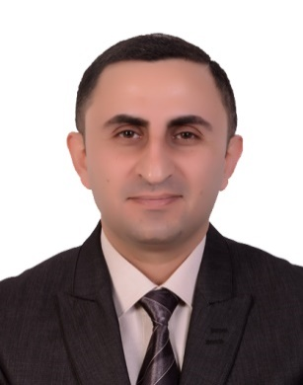

Dr. Ali A. Ramadhan

MBChB FIBMS (med.) FKBMS (G&H)

Dr. Ali Ramadan is a senior lecturer of gastroenterology and hepatology in the Department of Medicine, Medical School, University of Duhok. He is also a consultant gastroenterologist and hepatologist in the gastroenterology and hepatology center of Azadi Teaching Hospital in Duhok, he provides many diagnostic & therapeutic services.

He is a fellow of the Iraqi Board for Medical Specializations (FIBMS) in medicine since 2010 and Kurdistan Board of Medical Specialties (FKBMS) in gastroenterology and hepatology since 2014. He was appointed as the lead of department of medicine in 2015. He contributes to both under- and post-graduate medical teaching and training.

He has participated in many training courses, international conferences and workshops and is a member of the American Gastroenterological Association, American Society for Gastrointestinal Endoscopy and American College of Gastroenterology through which he keeps himself updated in the field of gastroenterology and hepatology.

