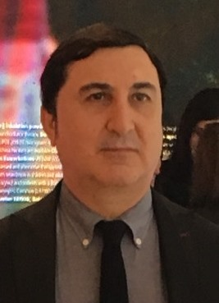

Dr. Jamal Basheer

MBChB MSc MRCP FRCP

Dr. Jamal Basheer is an associate professor of clinical medicine. He joined the college of medicine, University of Duhok in 1996. He made tremendous efforts in the success of this college especially in the early years of its establishment when the number of the academic staff was low.

Dr. Jamal Basheer is a member and a fellow of the Royal College of Physicians. He has been teaching both undergraduate and postgraduate students in Azadi teaching hospital. He also serves as specialist in the department of medicine of this hospital. He has participated in many training courses, international conferences and workshops. He published in pubmed indexed journals.

Dr Jamal Basheer, independently, started preparations and networking to arrange this conference. He managed to engage internationally recognized expert speakers, established the scientific committee, finalized the agenda, obtained RCP CPD approval and involved two international societies to endorse the conference in recognition of the high standard scientific agenda and the high quality of the speakers. Dr Jamal Basheer obtained adequate funding and support from the sponsors to hold this year’s conference with no financial burden to University of Duhok or any of Kurdistan Regional Government offices or institutions. In fact, the financial committee managed to ring-fence funding from the conference’s revenue to support Duhok Medical School’s other education and research activities. He similarly and single-handedly secured funding and chaired the first Endocrinology, Lipids and Vascular Conference January 2017 which was a huge success.

