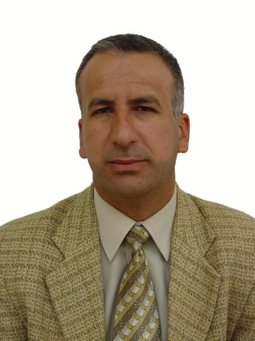

Professor Qasim Hasso Abdullah

MBChB MSc PhD

Professor Qasim is the Dean of College of Medicine in University of Duhok since 2016. He was the Vice Dean of College of Medicine in University of Duhok (2000 – 2005), Head of Medical Physiology and Pharmacology Department 2009 – 2018. He is a Member of management committee in Kurdistan Syndicate of Physicians (1998 – 2016).

He established Neurophysiology Unit at Azadi Teaching Hospital in 2000. He did supervision of five Ph.D., six M.Sc. and two High Diploma Students. He has 21 published articles in different national and international Journals in the field of experimental and clinical physiology. He is actively involved in teaching of medical physiology courses for undergraduate and postgraduate students. He participated in many thesis Discussions for awarding M.Sc. and Ph.D. degrees.

He has several appreciation letters from DoH, MoH, UoD, MOHE. He was involved in the management, arrangement and participation in scientific workshops, training courses and conferences in the field of medicine, particularly those concerning curriculum development and accreditation of medical colleges. Currently, he is a member of national assessors’ team for accreditation of medical colleges in Iraq.

