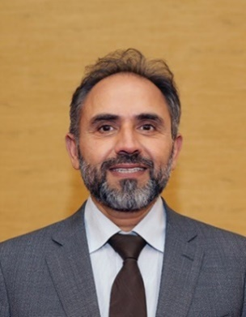

Professor Dr. Rayaz A. Malik

BSc. (Hons), MSc., MB ChB, PhD, FRCP.

Rayaz Malik graduated in Medicine from the University of Aberdeen in 1991, obtained his MRCP in 1996, PhD from the University of Manchester in 1997 and was elected to become a fellow of the Royal College of Physicians in 2007. He was appointed as Consultant Physician and Senior Lecturer in 2001 and as Professor of Medicine and Consultant Physician in 2008 in Central Manchester University Teaching Hospitals and the University of Manchester. He was appointed as Professor of Medicine at Weill Cornell Medicine in 2014 and is an honorary Professor of Medicine and Consultant Physician at Central Manchester University Teaching Hospitals and University of Manchester and visiting Professor of Medicine at Manchester Metropolitan University. He was appointed as the Organizational Official for Weill Cornell Medicine in Qatar in November 2016.

His research focuses on the pathogenesis, assessment and treatment of diabetic neuropathy and cardiomyopathy and is funded by the NIH, JDRF, QF, ECTRIMS and MJFF. He was called to provide expert advice to NICE on diabetic gastroparesis and painful diabetic neuropathy in 2014. Over the last 15 years he has pioneered the use of corneal confocal microscopy, a non-invasive ophthalmic instrument, to quantify diabetic and other peripheral neuropathies. More recently he has applied CCM to establish it as a surrogate for neuronal damage in patients with Stroke, Multiple Sclerosis, Parkinson’s disease and Dementia.

He was the President of Neurodiab (the diabetic neuropathy study group of the EASD) from 2009-2012. He is an associate editor for Diabetic Medicine (2006 to present); J of Diabetes and its Complications (2012-present), PLOS One (2016present), BMC Neurology (2009-present) and Advances in Therapy (2009present). He is on the Juvenile Diabetes Research Foundation Complications and Clinical Investigation Research Committee (2005-present) and served on the MRC Clinical Translational research panel from 2012-2014.

