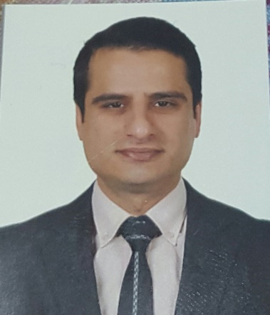
Full Name: Shwan Elias Abdulkareem
Date and place of birth: 23/9/1983 Erbil-IRQ

Passport Number: G1292180

Address: Kurdistan/Duhok/Avro city/Building B25/Flat number 31
Mobile: 07508596010
e.mail: schwan.ortho@gmail.com
Nationality: Iraqi/Kurdish
Gender: Male
Marital state: Married

Educational background:
-Bachelor of dentistry/2006/College of Dentistry/Al-Mustansiriya university.
-Master of science in Orthodontics/2012/ College of Dentistry/Baghdad University.

Areas of experience:
-Period from 6/2007 to 6/2008 as a rotator dentist in Duhok specialized dental center/Duhok/Kurdistan.
-Period from 6/2008 to 11/2009 as a graduated dentist in Azadi health center/Akre/Duhok/Kurdistan.
-Period from 11/2009 to 6/2012 as a master's student in College of Dentistry/Baghdad University/Baghdad/Iraq.
-Period from 6/2012 to 11/2012 as a specialized dentist in Duhok specialized dental center/Duhok/Kurdistan.
-Period from 11/2012 to 3/2016 as an assistant Lecturer in College of Dentistry/University of Duhok.

International activities:
-Attendance as a participant in AEDEC conference in Dubai for two years 2013 and 2014.
-Attendance as a participant in lingual orthodontic course in Dubai in 7/ 2015.
-Attendance as participant in Invisalign certification course in Dubai in 3/ 2015

Local activities:
-participant in workshop about health care in detentions/Irbil/Kurdistan/2008.
-Attendance of second medical conference of faculty of medical sciences/Duhok/Kurdistan.
-Participant in workshop about dental implants/school of Dentistry/Duhok/2013.
-Participant in workshop about prosthodontics/School of Dentistry/Duhok/2015.
-Participant in workshop about examinations/Faculty of Medical Sciences/Duhok/2015.
-Participant in Teaching methods course/University of Duhok/2015.
-Participant in workshop about sterilization/College of Dentistry/Duhok/2015.

Language:
English, Arabic and Kurdish.

Computer literacy:
Power Point, Word and Excel.

References:
-Dr.Bahar Jaafar Selivany (Lecturer/Dean of College of Dentistry/Duhok)
Tel: 07504544975
E.mail: dr.bahar_selivany@yahoo.com

Dr.Munther Kazanji (Assistant Professor/College of Dentistry/Duhok)
Tel: 07502089267
E.mail: munthern.kazanji@yahoo.com

