 | Personal Information |  | 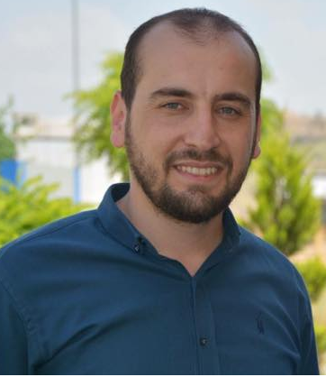
 | Full Name | Ahmed Jaddo Mohammed Ameen
 | Scientific Grade | Lecturer Assistant
 | Date and place of birth | May 18, 1987; Mosil, Akre
 | Citizenship | Iraqi
 | Marital status | Married
Address (Office) |  | Department of Biology  College of Education/ Akre  University of Duhok
Address (Home) |  | Iraq  Duhok – Akre
Phone |  | (+964) 750 7317097
Email |  | zebarichemistry@gmail.com
Mother language |  | Kurdish

Academic Titles Attained
Academic title
Date of attainment
Date of first assignment in University | 21/11/2011
Time in present position | 1 years

Employment History
November21, 2011 |  | Date of first assignment: Demonstrator. Biology Dept., College of Education, Salahaddin University – Erbil, Iraq.
Languages
 | Fluent | Very good | Good | Average | Below average
Kurdish | √
Arabic | √
English |  |  | √
Other

Education and Qualifications
M. Sc. Degree | Analytical Chemistry
Title of thesis | RP-HPLC Methods for the Determination of Some Antihypertensive Drugs in Pharmaceutical Formulations.
Date of attainment | March06, 2016.
Grade | Very good
B.Sc. Degree | Department of Chemistry, College of Education, University of Zakho – Duhok. Iraq.
Title of Research Project
Date of attainment | July, 2011
Grade | Good

Teaching / Advising Experience

Courses

Memberships

IT Skills
Good computer skills, Word, PowerPoint, Internet, Email and Excel-basic

References and attachment Documents
available on request

