Dr. Asaad Curriculum vitae

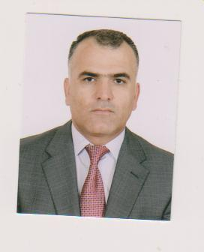
Name :-Asaad Shareef Omar
Date of birth:-1/7/1972
Marital status:-married , has four children
Address: - Duhok/masik
Tel.NO.:-07504578047
E-Mail:- drasaad1972@yahoo.com

Education
F.I.C.M.S (General Surgery) Baghdad 2011
M.B.CH.B (Duhok university )1999
Secondary school (Birayety school) 1993

Current position
Teacher in medical school ,faculty of medicine ,-
Duhok university and head of Department of surgery.
General surgeon in Azadi teaching hospital.-
- Active member of GIT center in Duhok

Previous position
-Head of surgical department in Zaxo hospital 2011-2012.
-Board student (SHO) inAzadi teaching hospital/Duhok ,2006-2011.
-Director of Amedi health distrect ,Practitioner in general surgery in Amedi hospital ,2005 -2006.
-SHO General surgery in Aadi and Emergensy teaching hospital /Duhok 2003-2005 .
-Manager of Sarsing health center 2002-2003.
-JHO in Azadi ,zaxo and Emergency hospitals ,1999-2002.

Research
Evaluation of causes of obstructive jaundice in Duhok 2009.-

Conferences and training courses
- training course on liver transplantation / Iran-Shiraz ,for one month,feb. 2013
- Istanbul International liver Imaging /Turky-Istanbul , four days ,April ,2013.
-kurdistan cancer conference /Erbil ,three days, April ,2013.
-Mesobotamiyamedical conferences in Duhok ,diyarbekir and Suleymania ,2011 ,2012 and 2013.
-Training course on upper and lower GIT Endoscopy ,Duhok GIT center for one year 2010.

