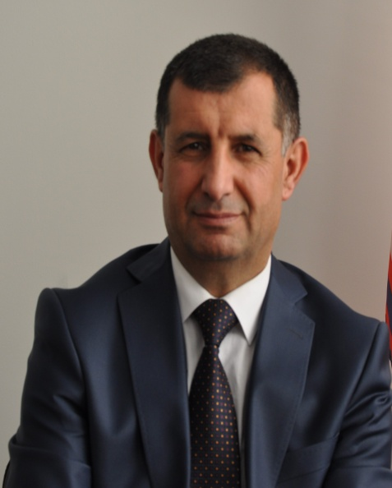
CURRICULUM VITAE

A. Personal information :
Name : Nadir Abdullah Garjees
Surname / Brifkani
Forename : Nadir Abdullah
Nationality : Iraqi kurdish
Native language : kurdish
Foreign language : Arabic and English
Date of birth : 05/08/1968
Place of birth : Duhok ,Iraq
Address : Heevy Pediatric Teaching Hospital ,Duhok , Iraq
Mobile : 009647504820882
E mail : nadir_brivkani@uod.ac

B- Qualifications :
University | Collage | Date of attendance | Degree awarded | Date of award | Main subject
Mosul  Mosul | Medicine  Medicine | 1/10/1985  1-10-2004 | M.B Ch. B  F.I.B.M.S | 11-9-1991  2007-2008 | General surgery and medicine  Pediatrics

C-Education

School | From | To
Fedah primary school (Mosul) | 1975 | 1980
Kefah secondary school (Mosul) | 1980 | 1982
Kawa preparatory school(Duhok) | 1982 | 1985

D- Current position
1- Lecturer of Pediatric in the medical college since 2007-2008
2-Head of Pediatric department since 2014

E- Previous posts
1- Junior house officer Azadi Teaching Hospital (1991-1993)
2- General practitioner (1993-2000)
3- Senior house officer Heevi Pediatric Teaching Hospital (2001--2004)

F- TRANNING COURSES:
1- Interactive course on practical pediatric by Royal College of pediatrics and Child health in Istanbul 2010
2- Elite Ped. GI Congress /Dubai 2015
3- The second Conference of Kurdistan Pediatric Society in Erbil 2015
G- Researches and publications:
1- Congenital Heart Diseases in Children of Down syndrome in Duhok ,2012
2-The effect of gender on the high grade vesicoureteric reflux among kurdish children in Duhok 2014
3- Post injection sciatic nerve injury in children in Duhok 2013
4- The role of Zinc deficiency in predisposition to febrile convulsion in Duhok 2015

H- The academic responsibilities include
Lecturer of Pediatric at the Department of Pediatric , College of Medicine, University of Duhok (Jan 2008 till know).

I- Membership of Associations/Committees
1- Member of Kurdish Medical association since Jan 1, 2002.

2- Member of Kurdistan Pediatric Society

3- Member of the International Iraqi Medical Association (iima) since 2008

